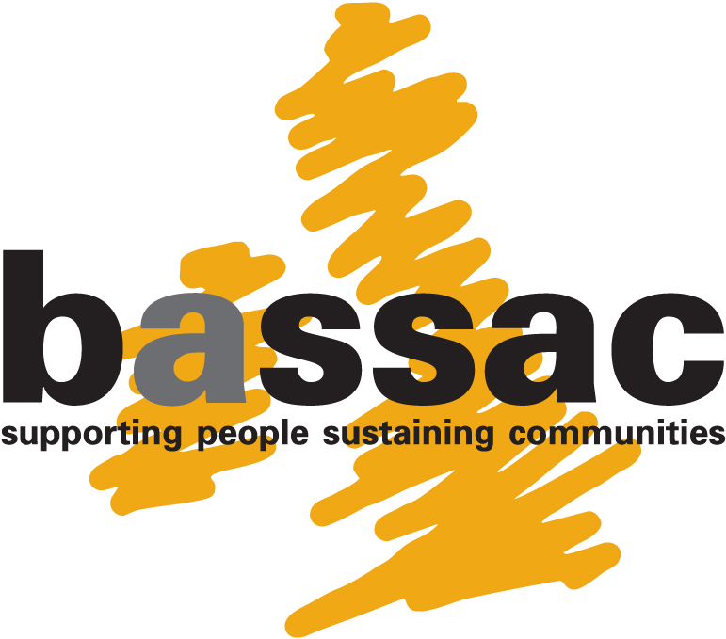

Operation Black Vote and BASSAC

OUR FUTURE IS IN OUR HANDS
Community Empowerment Roadshows 2010/11

BOOKING FORM

TOWER HAMLETS - SATURDAY 5TH FEBRUARY 2011 2010: 11.00 am – 3.30 pm

SOUTHWARK – SATURDAY 12TH FEBRUARY 2011: 11.00 am – 3.30 pm

Event details about this seminar will be sent to you upon receipt of this form.

PERSONAL DETAILS

Please TYPE or print using black ink and block capitals

Full Name ____________________________________________________________________

Full Postal Address _____________________________________________________________

_____________________________________________________________________________

Daytime Telephone ___________________________ Mobile ___________________________

Home Telephone _____________________________ Email ____________________________

Male/Female Date of Birth Ethnic Origin Religion/Faith Languages

__________ ___________ ___________ ___________ ___________

Where did you hear about the seminar? _________________________________________

Please indicate which seminar you would like to attend: TOWER HAMLETS / SOUTHWARK

Please complete the following sections, which is only used for OBV’s research about Black and Minority Ethnic (BME) Community Engagement and will not affect your selection for the seminar

EMPLOYMENT
Present or most recent employment (paid or voluntary) __________________________________

Name and Address of Employer ____________________________________________________

______________________________________________________________________________

Post Held ________________________ Date Started ___________________________________

Details of Position _______________________________________________________________

EXPERIENCE

Do you have any voluntary/civic/political experience within your local area? Yes / No

If so, please state ________________________________________________________________

How long have you resided in your local area?

Less than 1 year 1-5 years 6-10 years 11+ years

   

Any Other Comments

______________________________________________________________________________

______________________________________________________________________________

Post, Email or Fax to:

Post: Merlene Carrington, Project Manager
OBV, 18a Victoria Park Square, London, E2 9PB
Fax: 0208 983 5492
E-mail: merlene@obv.org.uk (please mention “Our Future” in the subject field)
For any further information, please telephone OBV on 0208 983 5430

THIS FORM MAY BE PHOTOCOPIED

