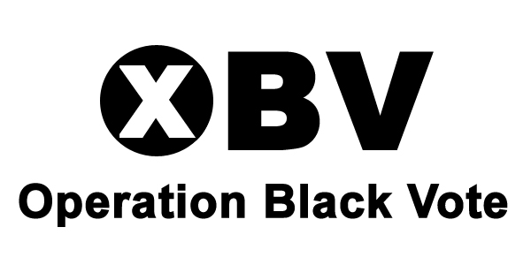

Operation Black Vote & Lewisham Council
Civic Leadership
Programme
A n

Application Form

Closing date for completed applications 31st January 2011

⎯⎯⎯⎯⎯⎯⎯⎯⎯⎯⎯⎯⎯⎯⎯⎯⎯⎯⎯⎯⎯⎯⎯⎯⎯⎯⎯⎯⎯⎯⎯⎯⎯⎯⎯⎯⎯⎯⎯⎯⎯⎯
Family Name/surname:

Forename(s)/given name(s):

Address:

Postcode:

Telephone – Home: Telephone – Work:

Mobile: Email address:

Do you live or work in Lewisham?

Where did you hear about the scheme?

Which area(s) of public life are you interested in?
You may tick as many areas as you wish:

School Governor Trustee Health Board Safer Neighbourhood Panel Councillor
    

Present or most recent employment: (paid or voluntary)
Job title:

Name and address of employer:

From (month, year): To (month, year)

Summary of key responsibilities:

Previous employment:
Please record your career history starting with the most recent:

Dates Employer and address Job title
(month, years) with brief explanation of responsibilities

Education and qualifications:
Please list all training and qualifications, including GCSEs, NVQs and A level or equivalent and any further education qualifications including degrees or equivalent, starting with the most recent.

Dates Further education establishment/ Qualifications
(years) School name

Voluntary experiences: Please list your volunteering experience, starting with the most recent.

Dates Where you volunteered What you did

Experience/relevant skill and further information
Black and other minority ethnic communities are under-represented in many areas of public and civic life. Please state why you would like to be a participant on Lewisham’s Civic Leadership Programme and how your experience, achievements and understanding of the concerns of minority communities would make you an ideal candidate for this scheme. You may continue on a separate sheet if necessary. (Max 400 words)

References:
Please detail two people who know you in a work or professional capacity. They will only be contacted if you are offered a place on the programme.

Name: Name:
Company: Company:
Address: Address:
Tel: Tel:
E: mail: E: mail:
Relationship to you: Relationship to you:
Length of time you have known them: Length of time you have known them:
⎯⎯⎯⎯⎯⎯⎯⎯⎯⎯⎯⎯⎯⎯⎯⎯⎯⎯⎯⎯⎯⎯⎯⎯⎯⎯⎯⎯⎯⎯⎯⎯⎯⎯⎯⎯⎯⎯⎯⎯⎯⎯⎯⎯
In accordance with the Data Protection Act 1998 I give my consent for the information contained in this form, including any defined as ‘sensitive personal data’, to be processed in accordance with the policy of Operation Black Vote for the purposes of recruitment. I understand that if I offered a place, this application form will form part of my personal file and that if I am not appointed it will be stored so that details of future schemes and OBV events can be sent to me.

I confirm the information I have supplied above is, to the best of my knowledge, true and accurate. I understand that deliberate misrepresentation or omission of factual information may lead to removal from the scheme.

If offered a place, I am prepared to accept the conditions and fulfil the requirements set out in the Programme Outline.

Signed: Dated:
Please return the completed form no later than the closing date shown at the top of page 1 to:
Francine Fernandes, Head of Shadowing Schemes,
Operation Black Vote, 18a Victoria Park Square, London, E2 9PB.
We accept emailed applications to: civicleaders@obv.org.uk

Please note: Interviews will take place in Lewisham in March 2011
(Candidates will only be invited to attend one interview date)

PLEASE COMPLETE MONITORING FORM (Page 4)
Operation Black Vote & Lewisham Council
Civic Leadership
Programme

Equal Opportunities Monitoring Information - Confidential

OBV is committed to promoting equal opportunities and to ensure that the equal opportunities policy is effective, it necessitates the collection of information regarding the applicant’s ethnic origin, faith, gender, and disability. The information you provide will be treated in the strictest confidence.

Name: ______________________________________________________________

Ethnic Origin:

Faith: ___ ______________________________

Date of Birth: ___/___/___

Gender: Male Female

Do you currently or have you previously considered yourself as trans-gender? Yes No

Sexual orientation: Please indicate which sexual orientation you identify as:

Bisexual Gay Heterosexual Lesbian

Do you consider yourself disabled? _________________________________

If so what is the nature of your disability? _____________________________

Do you require any assistance to enable you to attend an interview e.g. signing, interpreter, wheelchair access etc?

Yes No

If yes, what type of assistance? _____________________________________

Signed: Date:
______________________________________________________________

Please ensure this document is completed in full and returned with your application form.

Thank you

